Handbook for Incoming Guests

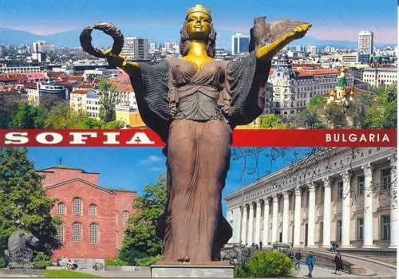

XIX International Scientific Conference
ECONOMIC GROWTH, BUSINESS PROSPECTS, MARKET POSITIONING IN TIME OF CRISIS
April 12-13, 2024

International Business School, Sofia
Content

An Introduction to the International Business School 3
Getting to the Distance Learning Centre, IBS 4
Contact Person: 5
An Introduction to Sofia 6
Visiting Sofia – practical information 9
Tourist Attractions 12
Country information 13

An Introduction to International Business School
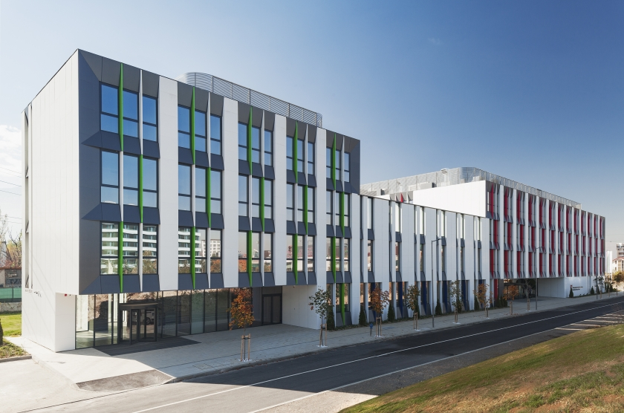
International Business School (IBS) is founded in 1991 as an independent, politically unrelated, private higher school. IBS is accredited by the National Evaluation and Accreditation Agency of Republic of Bulgaria.
IBS offers Bachelor, Master and PhD Programs in the following professional fields: Administration and Management, Economics and Tourism. IBS uses the European Credit Transfer and Accumulation System thus contributing to the objectives of the European Higher Education Area – high quality and transparency of the education process and more opportunities for student mobility. Along with the traditional academic forms of education – full-time and part-time – IBS applies distance learning as a contemporary educational approach with a flexible learning process – no compulsory attendance in classes.
The Distance Learning Centre of IBS executes education in a new building combining traditional and modern technologies, which has been nominated as "Building of 2017" in the section of "Education sector".
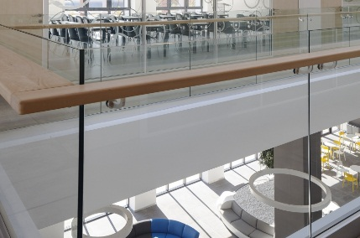 | 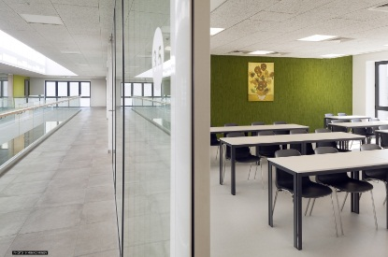 | 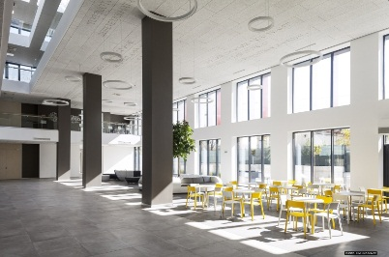
Getting to the Distance Learning Centre, IBS

Sofia 1407  7 Vincent van Gogh Str.  Distance Learning Centre /DLC/  phone: +359 (0)2 4001630 +359 (0)2 4001631  e-mail: doinfo@ibsedu.bg | 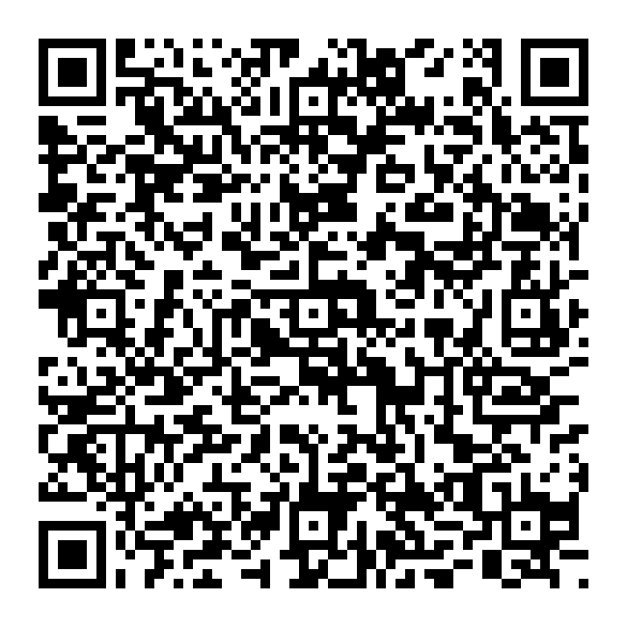

GOOGLE MAP LINK TO THE VENUE
Coordinates: 42.65597219365486, 23.317911262524547

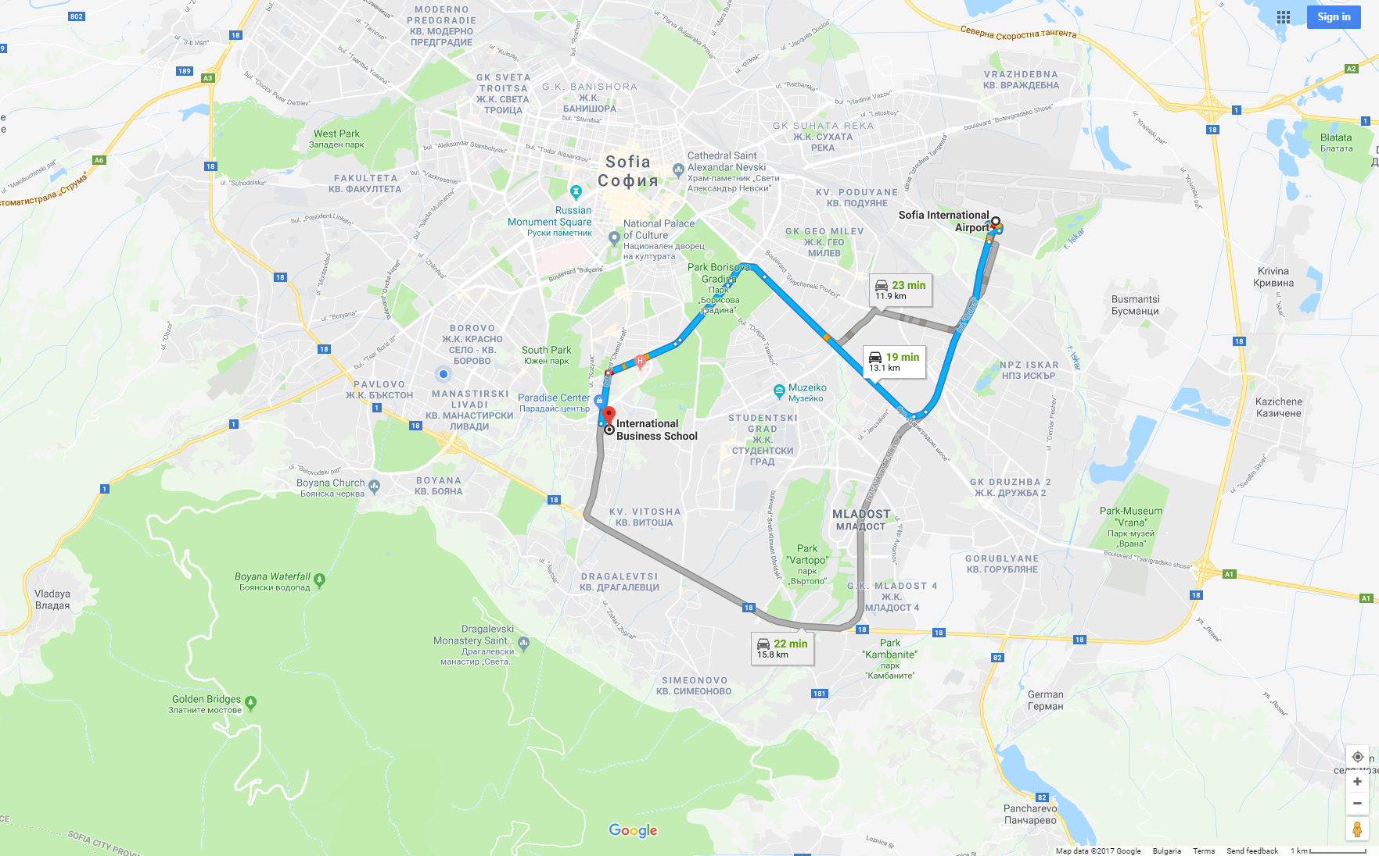
Location – next to the Paradise Mall
Public transport – bus stop “Vitosha”
Metro station – “Vitosha”
WiFi
Network: IBS-Students
Password: ibsedudlc

Contact person:
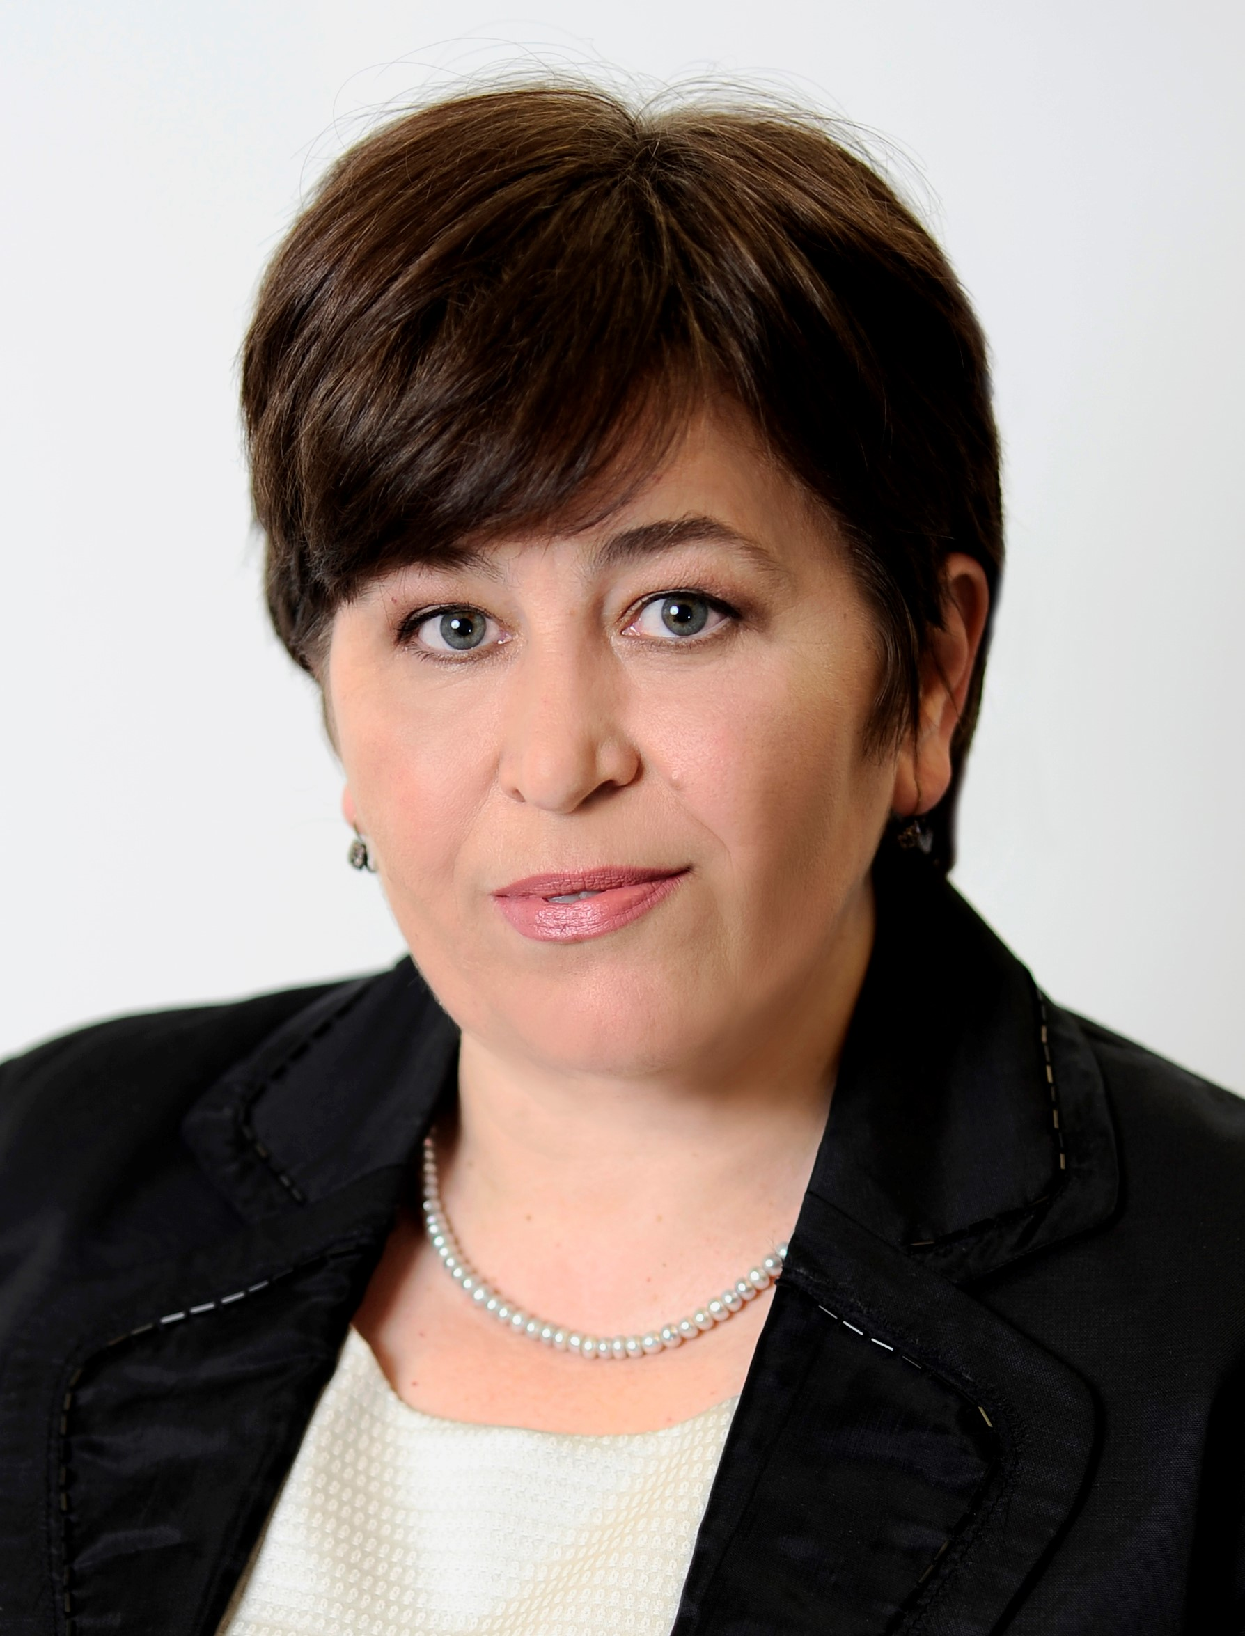 | Stela Baltova, PhD  Assoc. professor  Vice-rector  Research & Int. Cooperation  +359 (0)2 400 1631  sbaltova@ibsedu.bg

An Introduction to Sofia

Sofia is Bulgaria’s capital and its largest city. Founded thousands of years ago, today the city continues to develop as the country’s cultural and economic centre. At present, the city has a population of 1,250,000.
Sofia is located in the western part of the country, on The Sofia Plain and on the lower slopes of Mount Vitosha. The city is located at a strategic crossroads. The route from Western Europe to Istanbul passes through Sofia via Beograd and Skopje, then through Plovdiv to Turkey. Sofia also connects The Near East and The Middle East, lying between the banks of The Danube and the shores of The White Sea on the one hand, and between The Black Sea and The Adriatic on the other.
Sofia is relatively close to the capitals of most Balkan countries: Ankara is 1,012 km; Athens is 837 km; Beograd is 374 km; Bucharest is 395 km; Zagreb is 762 km; Ljubljana is 897 km; Sarajevo is 549 km; Skopje is 239 km; Tirana is 553 km. Three freeways begin in Sofia: Trakia, Lyulin, and Hemus. The Sofia Airport provides travelers with convenient connections to all major European cities, and from the central train station and bus station passengers can reach every destination in the country.

Sofia has been settled for many millennia. In honor of its hot springs, in the 8th century BCE the Thracian tribes settled here gave the city its first name – Serdika or Serdonpolis.In the 1st century BCE, Serdika was captured by the Romans, who transformed it into a Roman city. During the reign of Emperor Marcus Ulpius Trajan (reign 98-117 CE), the city took his name, Ulpia Serdika, and became the administrative center of the region. Serdika was the favorite city of Constantine the Great (reign 306-337), who said “Serdika is my Rome.” In roughly 175, massive fortified walls, with four watchtowers were built to protect the city, and a second outer fortified wall was added during the 5th-6th centuries. The city’s flourished for a second time under Justinian the Great (reign 527-565). At the beginning of the 9th century, the Bulgarian Han Krum (reign 803-814) invaded Serdika. The city became an inseparable part of The First Bulgarian Empire (7th-9th centuries) under Han Omurtag (reign 814-831). At this time the city was renamed Sredets (The Center), because of its central strategic location. From 1018-1094, Sredets was under Byzantine rule, but still remained an important strategic, economic, and cultural center. During the time of The Second Bulgarian Empire (1185-1393), Sredets took on the appearance of a large Medieval city – its narrow, crowded streets witnessed the construction of more and more small churches and monasteries, which later became Sofia’s Holy Mountain. The city gained its present name at the end of the 14th century, in honour of the city’s major symbol, The Saint Sofia Basilica. In 1382, the city fell to the Ottomans. It was liberated five centuries later, in 1878, and on April 3, 1879 it was declared the capital of the newly-liberated Bulgarian nation.

Sofia preserves many valuable monuments to its long and storied past. Visitors exploring the city’s streets can see remnants of The Eastern Gate from the days when Sofia was Serdika and Sredets, dating from the 2nd-4th centuries CE. These remains are exhibited in the underpass connecting the Presidential Palace and The Ministerial Council, surrounded by shops selling traditional Bulgarian souvenirs and rosewater.
During the months of May and June, The Palace of Culture will welcome performers participating in the festival “Sofia Music Weeks.” The capital’s many theatres and galleries offer a wide range of interesting exhibits and shows.
The city is a preferred destination for international congresses, and there are a great many halls and centres offering possibilities for every need. For example, one of the city’s most popular venues for business forums and trade fairs is The National Palace of Culture.
Sofia is also home to Bulgaria’s most prestigious and larges educational institutions.
Near Sofia, in the Vitosha, Lozen, and Stara Planina (Central Balkan) Mountains, over the centuries so many monasteries have been founded that they came to be known as Sofia’s Holy Mountains. They can be considered as a single complex, and played an important role in preserving the Bulgarian spiritual heritage during the centuries of Ottoman occupation. Still standing are The Dragalevski, Lozen, Germanski, Kremikovski, Cherepishki, and Osenovlashki Monasteries, among others.
Opportunities for sport and recreation in the capital are many and varied – outdoor swimming pools, tennis courts, modern gymnasiums and sports halls, and parks. The city’s stadiums draw thousands of fans for matches between major football teams. Sofia’s parks are a favourite place for rest and recreation. Borisov Park is right in the centre of the city, and South Park is next to the National Palace of Culture.
Like every big city, Sofia has something for every taste. There are a great many luxury hotels, including those that are part of international hotel chains. There is also a wide variety of hostels and smaller family guesthouses. There are a multitude of discotheques, restaurants, bars, piano bars, folk clubs, taverns, soda fountains, fast food outlets and many other kinds of entertainment.
The city’s annual celebration is observed on September 17, in honour of the martyrdom of Saint Sofia and her three daughters Vyara (Faith), Nadezhda (Hope), and Lyubov (Love).
For more information:
- https://www.visitsofia.bg
- https://www.lonelyplanet.com/bulgaria/sofia
- https://urban-wanders.com/a-complete-travel-guide-to-sofia-bulgaria/
https://bulgariatravel.org/
Visiting Sofia – practical information

- Currency
Bulgaria’s currency is lev (BGN). The lev is fixed to the Euro at a rate of approximately 2 lev to 1 Euro (1.95 leva = 1 Euro). Hotels, shops, taxis, restaurants accept payments in lev only. Credit and debit cards are generally accepted everywhere.

- Travelling to Sofia
Recommended transport from / to the airport, please visit:
https://sofia-airport.eu/en/access/

Metro map:

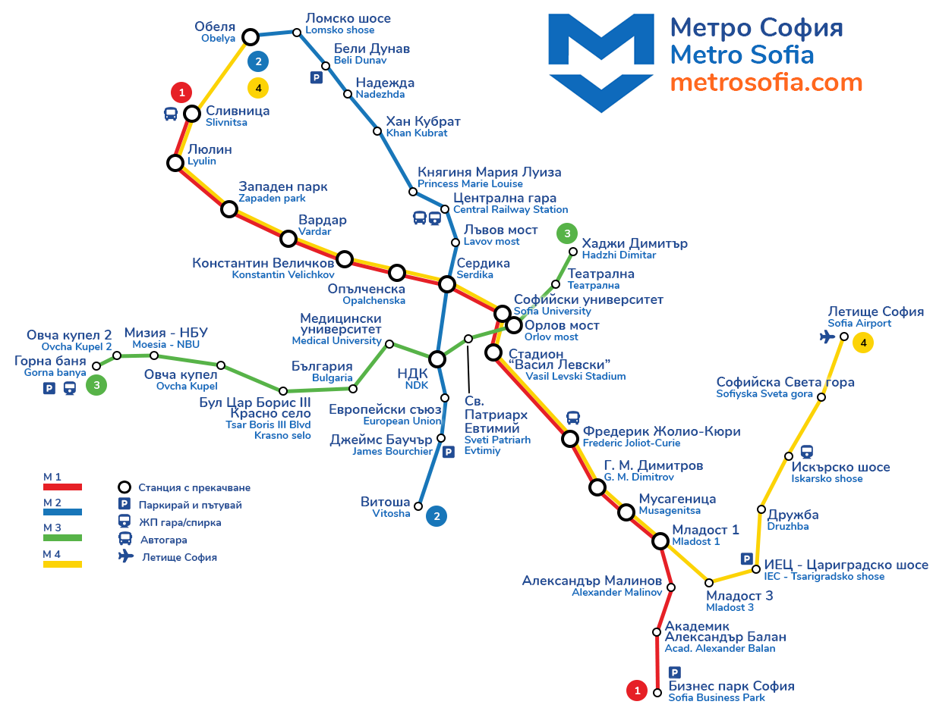

Tourist Attractions
The Best Things to Visit in Sofia
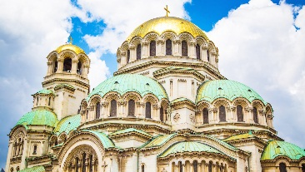 | Alexander Nevsky Cathedral  This Orthodox Church, with its golden dome, is one of the largest in the world. The crypt houses a great collection of religious art that dates from as early as the 9th century.
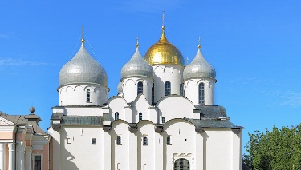 | Saint Sofia Church  Constructed in the 6th century, the church stands on the site of earlier churches and a necropolis, with mosaics that archaeologists have unearthed during excavations.
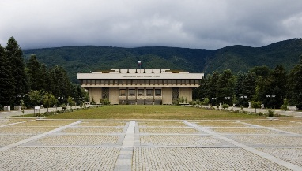 | National History Museum  Bulgaria's largest museum contains a great exhibition on its history, extending from the Paleolithic era to today. Pieces include jewellery, weapons, and historical documents.
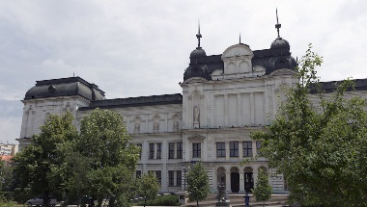 | National Art Gallery  Bulgaria's former royal residence contains the country's most important collection of artwork by prominent Bulgarian artists from the 19th and 20th centuries.
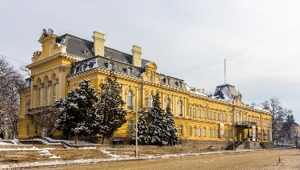 | National Palace of Culture  Built in 1981 to celebrate Bulgaria's 1300th anniversary, the huge congress hall boasts greenery with fountains and modern artwork. An underground arcade also provides shops and eateries.
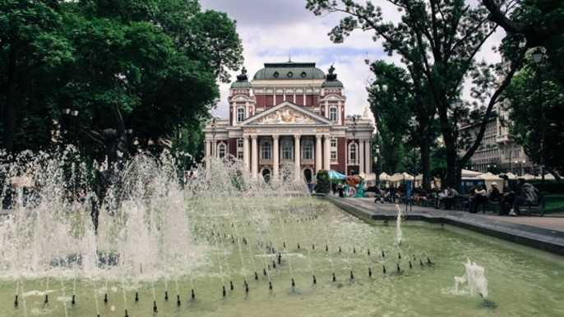 | Ivan Vazov National Theatre  The “Ivan Vazov” National Theatre is the oldest and most imposing theatre in the country. This theatre is one of the major landmarks in Sofia due to its prime location and grandiose architecture.
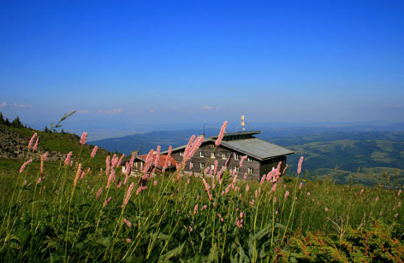 | Mount Vitosha  Vitosha Mountain is the oldest nature park on the Balkan Peninsula. Its gorgeous silhouette is visible from almost all positions in the city and is inseparable part of Sofia’ image.  … and many more.

Country information

Area – 110,994 square kilometers (42,855 square miles)
Population – 7,606,551 inhabitants
Capital City – Sofia
Currency – Bulgarian Lev (BGN) (plural Leva)
Language – Bulgarian
Time Zone – Еastern European Time: GMT plus 2, no time zones within the country.
Country Phone Code – 00359 Area
Phone Code (Sofia) – 02
Electricity: the electricity is 220 Volts AC, European 2 round pin plugs

Weights and measures: Bulgaria uses the metric system for all weights and measures. To convert metres into feet divide by 0.3048; to convert kilometers into miles divide by 1.6083; to convert kilograms into pounds divide by 0.4536; to convert hectares into acres divide by 0.4047. To convert imperial into metric multiply by the factors shown.

Tipping: tips of 10% of the bill are appropriate for waiters and taxi drivers.
Bank Opening Hours: Monday–Friday 09:00–16:30
Healthcare: no vaccination is necessary.
Airlines: Bulgaria Air
Airport name: Sofia International Airport
Distance to city centre: 10 km from downtown Sofia
Access Information: bus route 84 (Terminal 1) and bus route 284 (Terminal 2)
Number of international airlines: 21
Number of international trains daily: 11
Highways: E79, E80, E871

